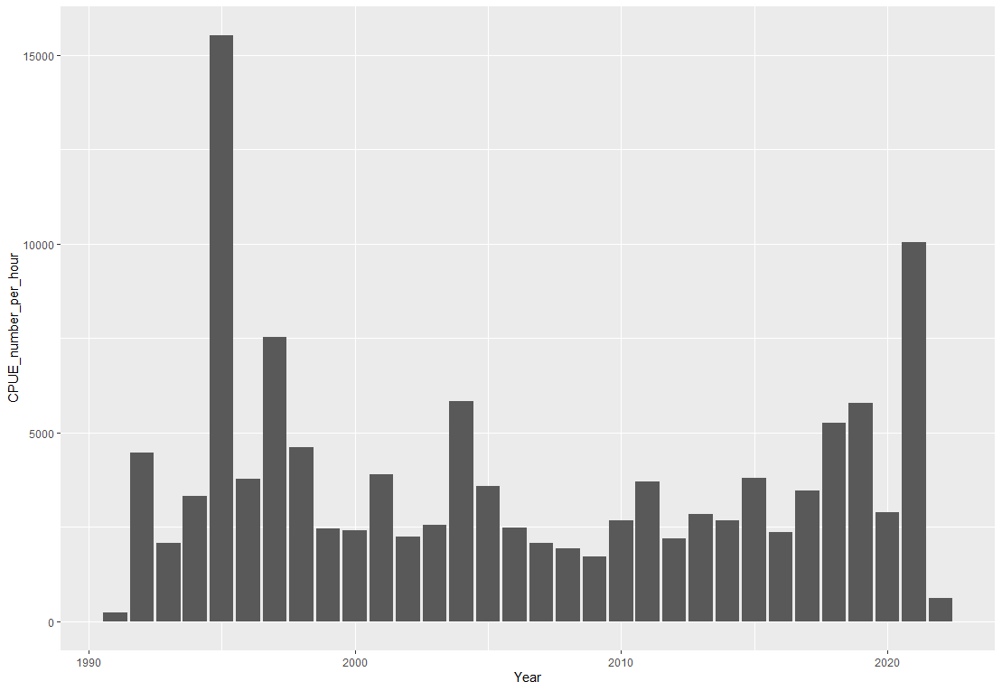

Fig.1 the bar chart shows the fluctuations of the CPUE per hour for WBC (western Baltic Cod) in a period of 32 years. this chart includes the catch per numbers of WBC in 3 quarters of the year in Area numbers 21,22,23 and 24 in the ICES data set map.

CPUE is an indirect indicator for measuring the abundance of WBC exploitation, therefore a high CPUE rate can show a high number of WBC, as we can see in the years 1995 and 2021. Also, a decreasing rate can translate into overexploitation as it appears in the years 1991 and 2022.

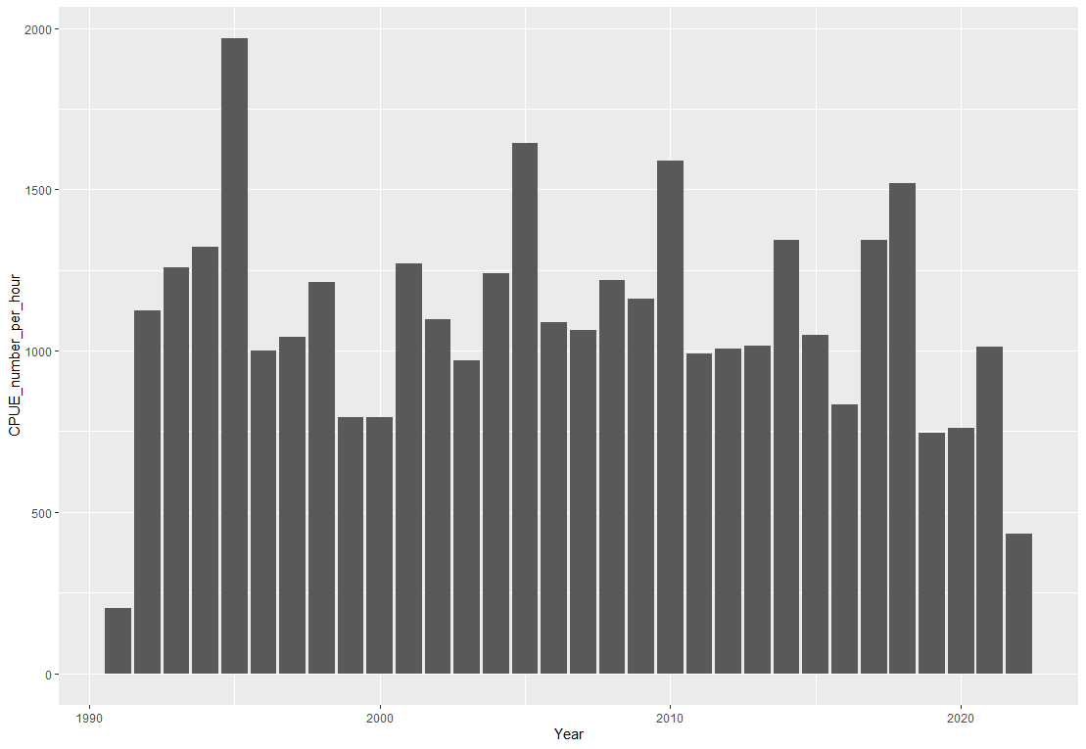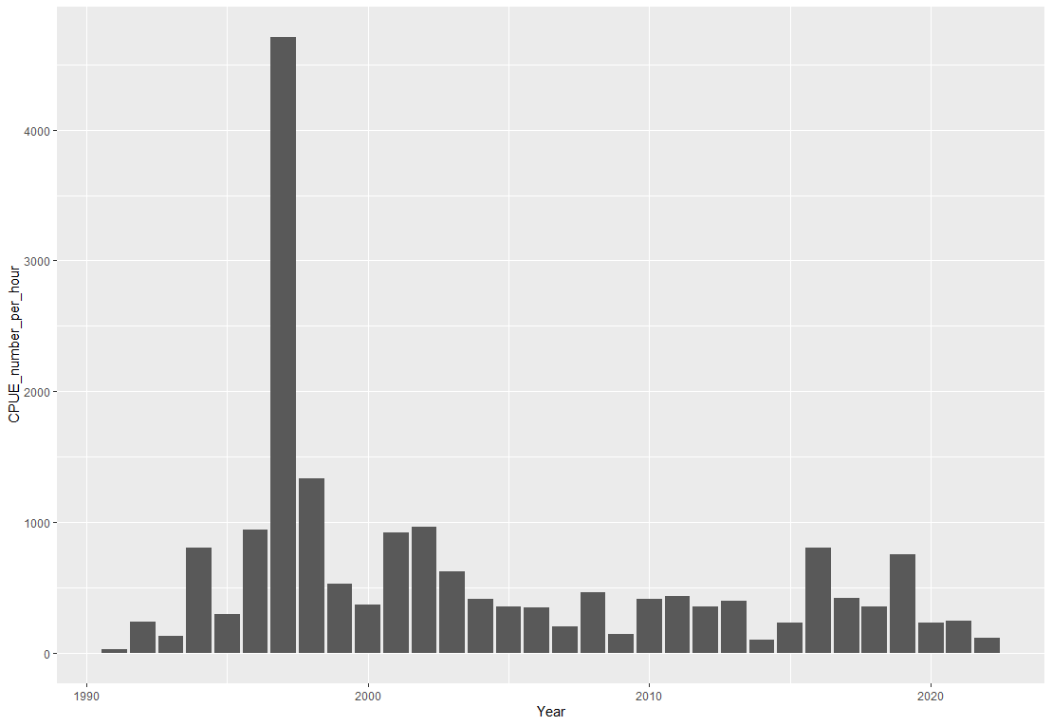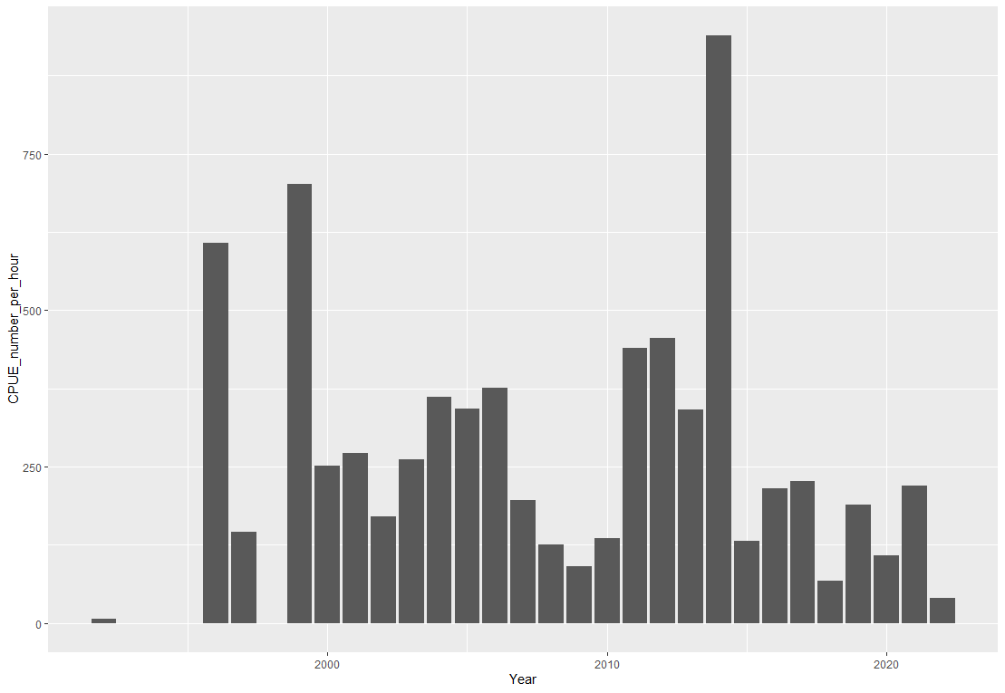

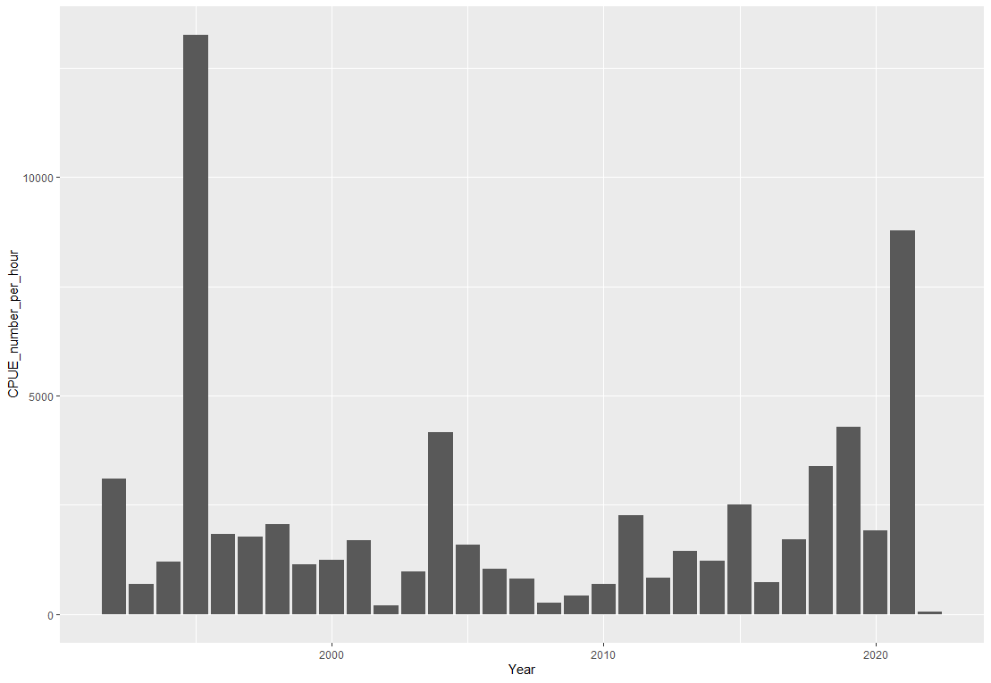 Area 21 Area 22

Area 23 Area 24

Fig.2 the WBC CPUE per hour rate divided by the Areas

a glance at the charts shows the high abundance of the WBC in Area 24 compared to the other areas, Area 24 experienced more sustainable exploitation. Area 22 also demonstrates almost sustainable exploitation except in the year 1997. Despite the declining rate in all areas, area 23 indicates the sharpest decrease compared to last year.

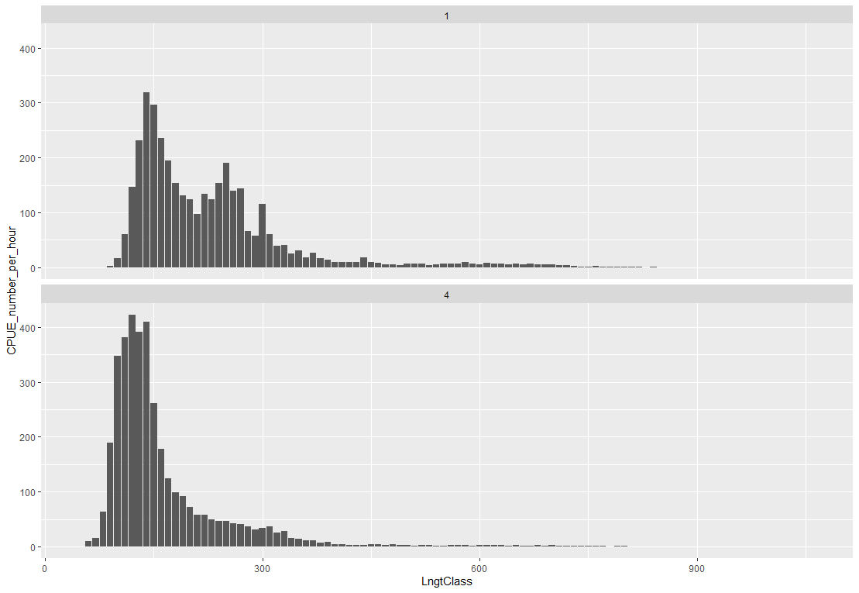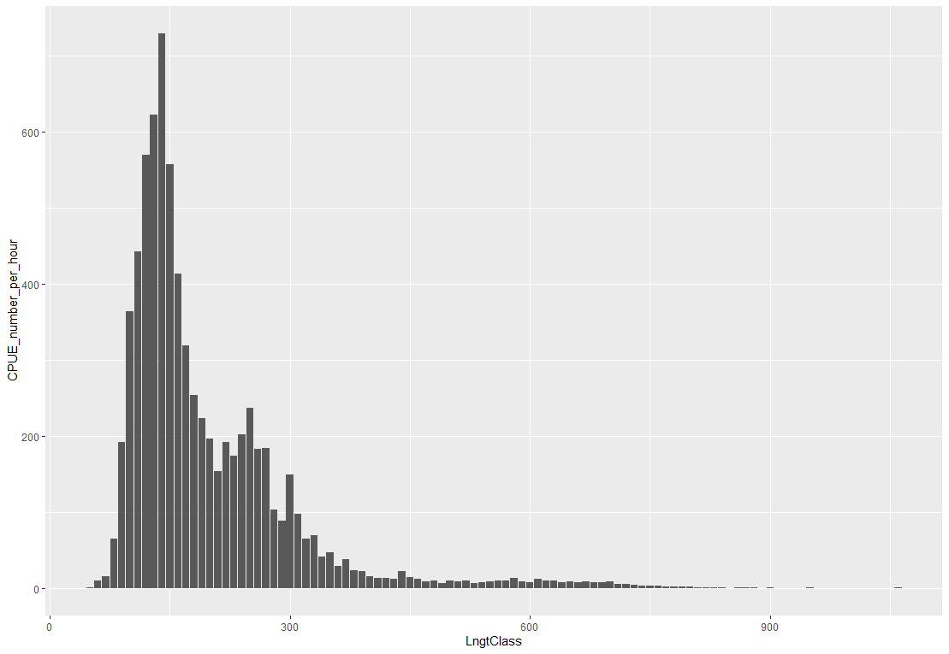

Fig.3 the CPUE per hour per length classes in area 21 in two quarters of the year. units for the length classes are in millimeters and for the CPUE measured as Catch in numbers per hour of hauling.

At first impression, the bigger WBC will face lower availability. Like many normal distribution graphs, the highest rate is expected in some certain length classes and after that, a downward trend existed as we can see in the 4th quarter. However, in the first quarter, the number of WBC catch varied in different length classes. Therefore, less exploitation in 3 different length classes can point to less interest in fishing or less availability.

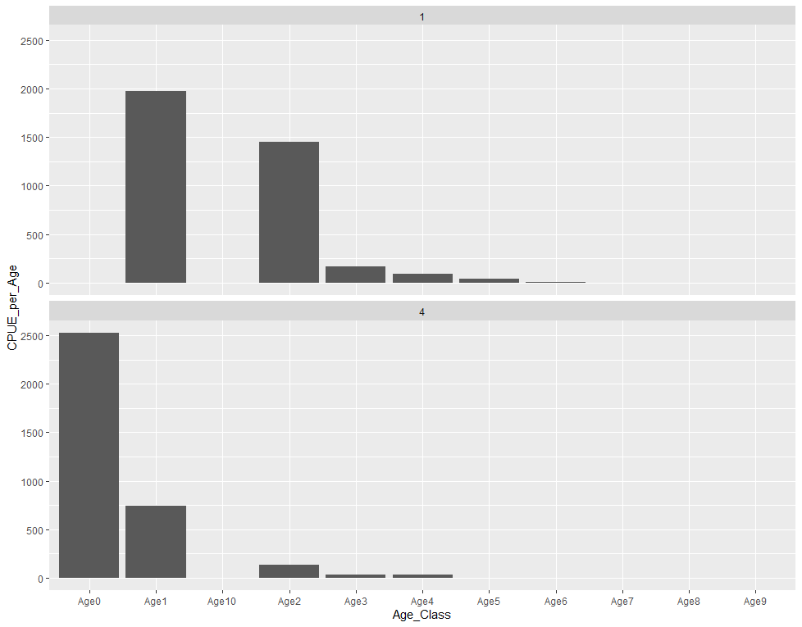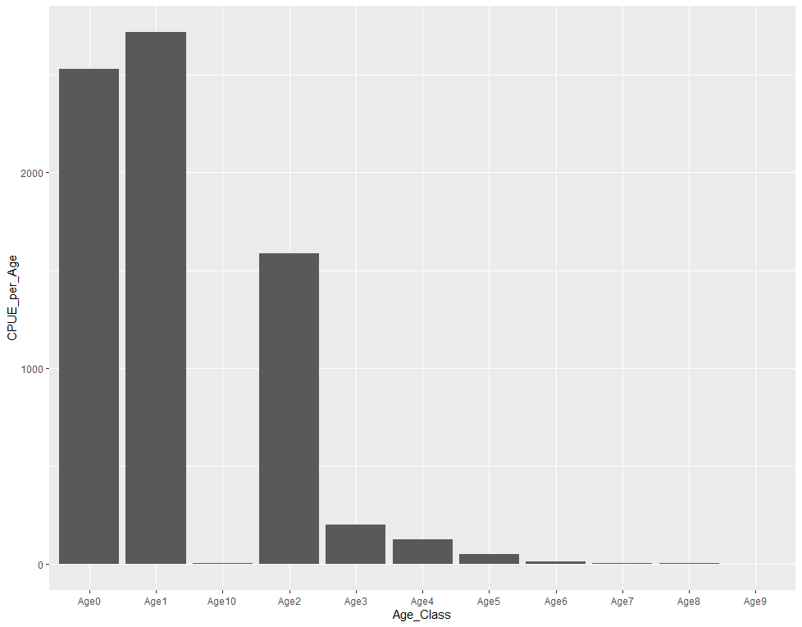

Fig.4 CPUE (Catch in numbers per hour) per age class in area 21 in two quarters of the year.

A decreasing trend in the survey can lead to lower availability in older WBC. In the first quarter, there is no observation for the first and 7th age classes, however, the highest rate is shown in the first age class. Also, there is no observation for the 5th age class in the 4th quarter of the year. These results can point out possible migrations and recruitments.

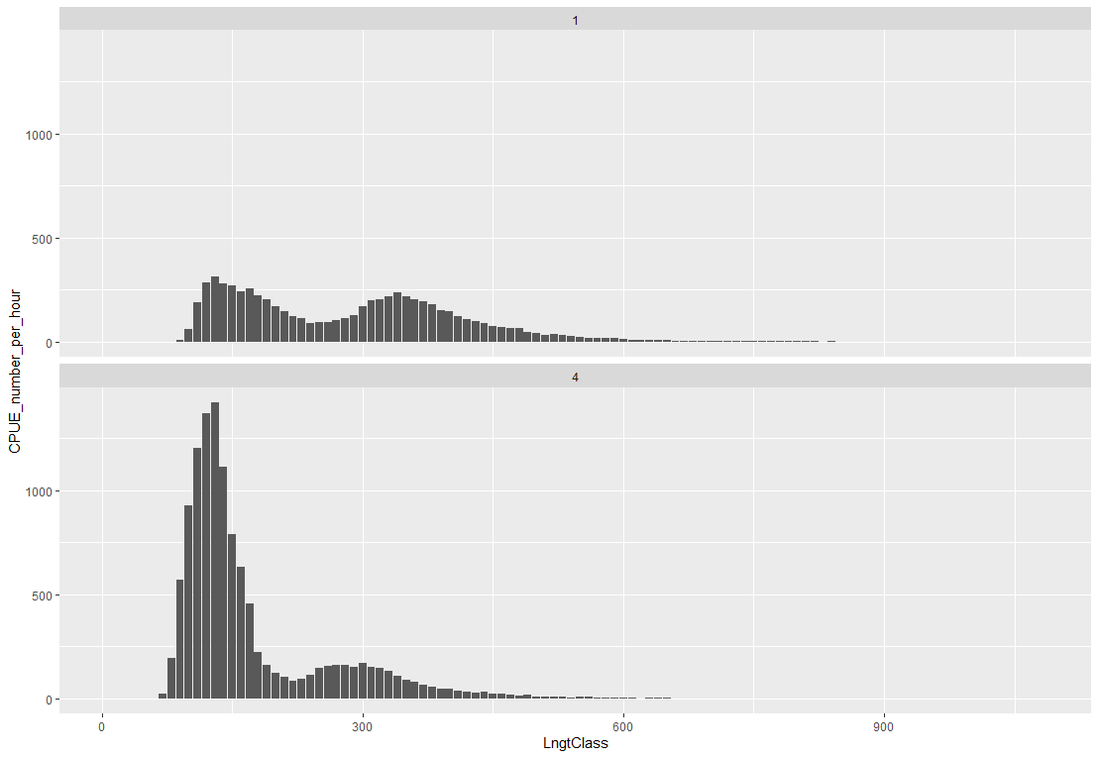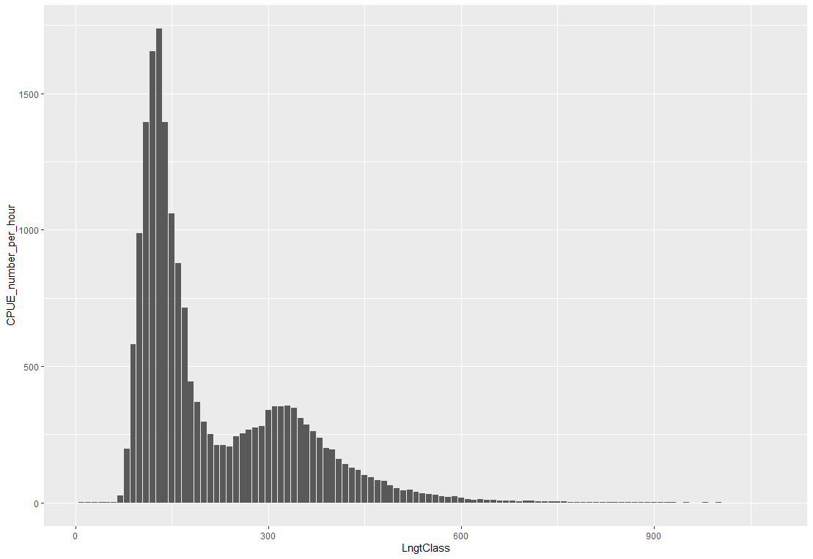

Fig.5 the CPUE per hour per length classes in area 22 in two quarters of the year. units for the length classes are in millimeters and for the CPUE measured as Catch in numbers per hour of hauling.

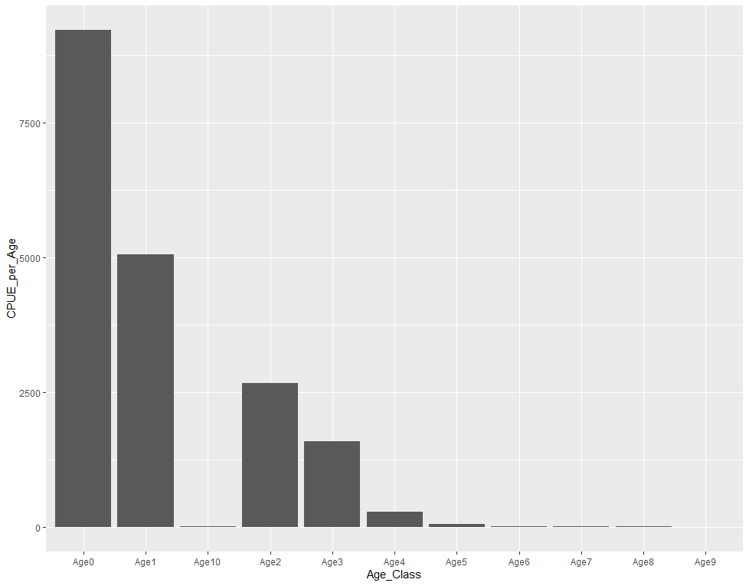Results for this area are mostly similar to those in area 21 whit the exception of a difference in abundance in comparison to the first quarter in area 22.

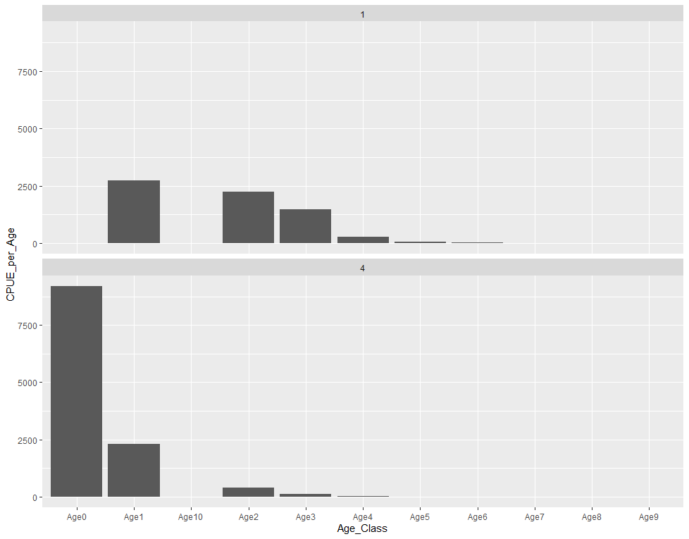

Fig.6 CPUE (Catch in numbers per hour) per age class in area 22 in two quarters of the year

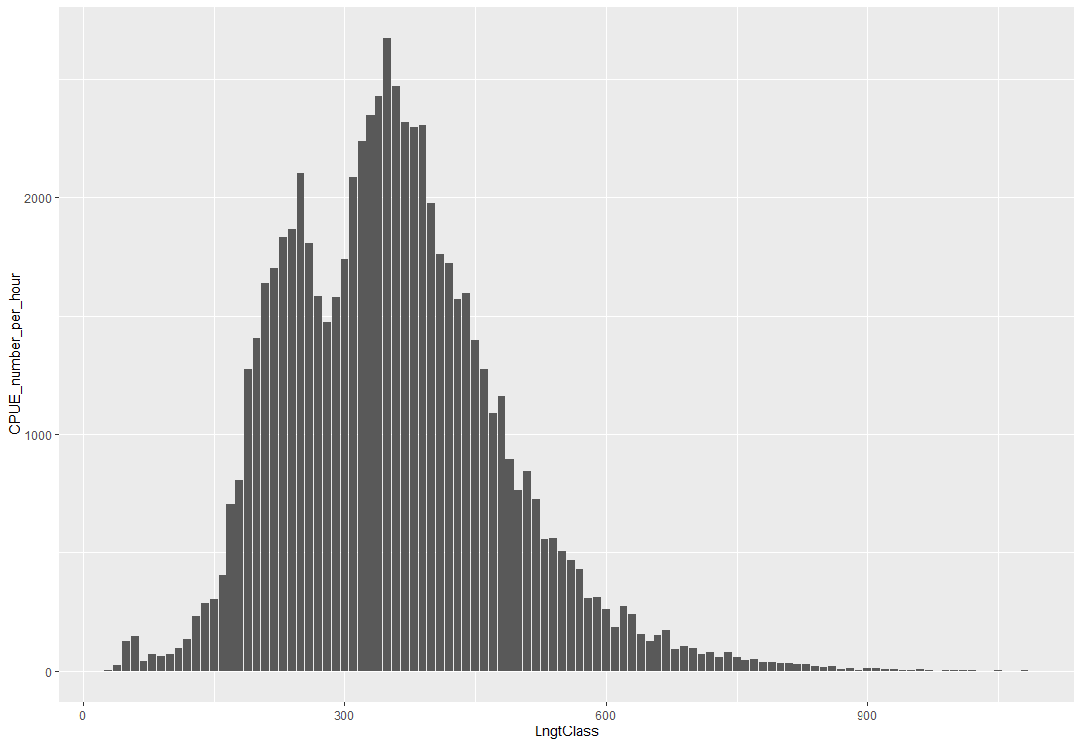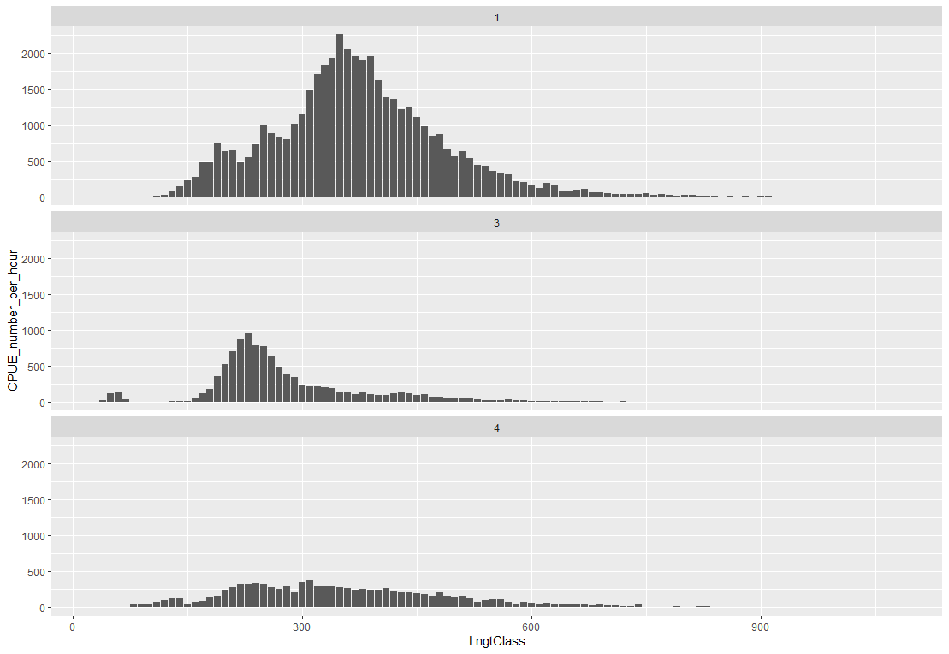Fig.7 includes CPUE per length class in Area 23 for 3 quarters of the year.

In this area, the main observations are in higher-length classes which demonstrates a higher abundance of large WBC. In comparison to the last areas, the main observations are in the first quarter and third quarter. These results can show area 23 as a possible migration destination during spring and fall.

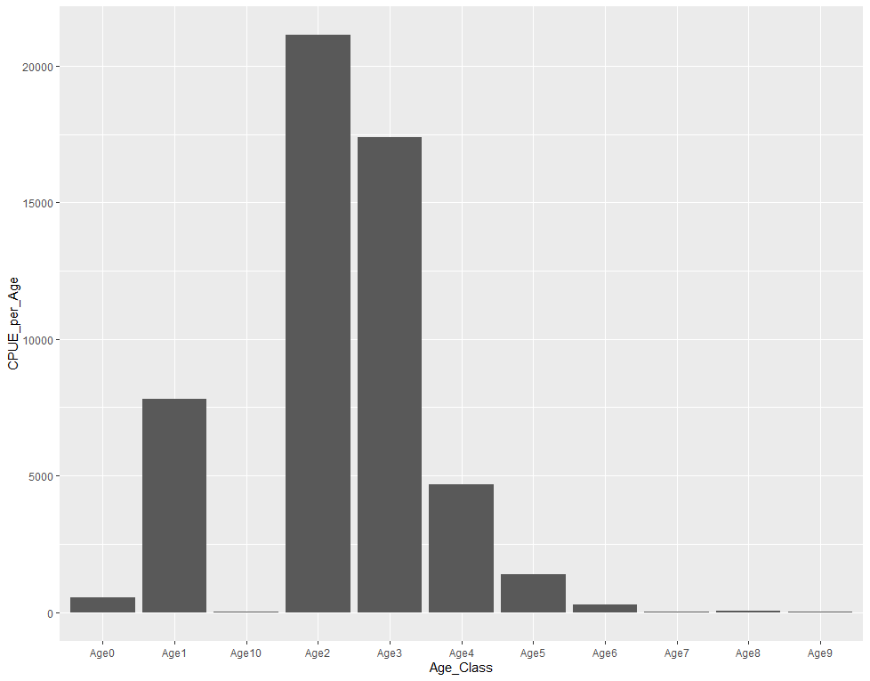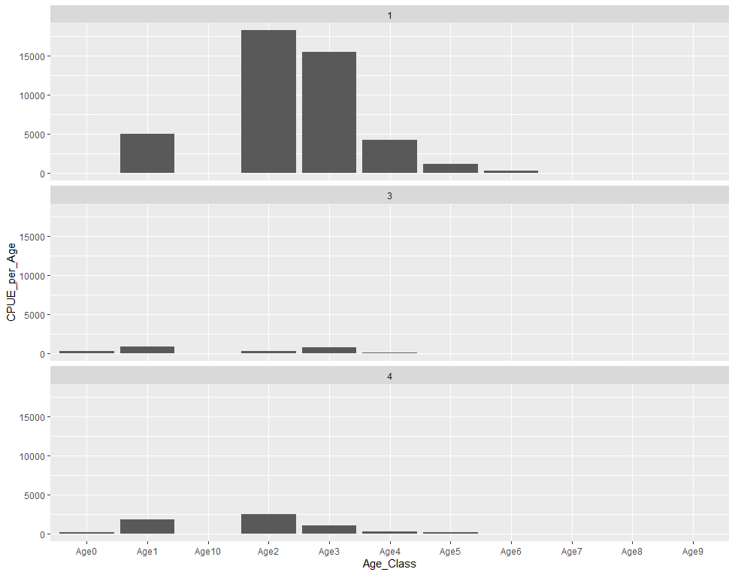

Fig.8 CPUE (Catch in numbers per hour) per age class in area 23 in 3 quarters of the year

The continuity of age and size can confirm the results mentioned in Fig.7. the highest abundance of observations in 2nd and 3rd age classes in the first quarter.

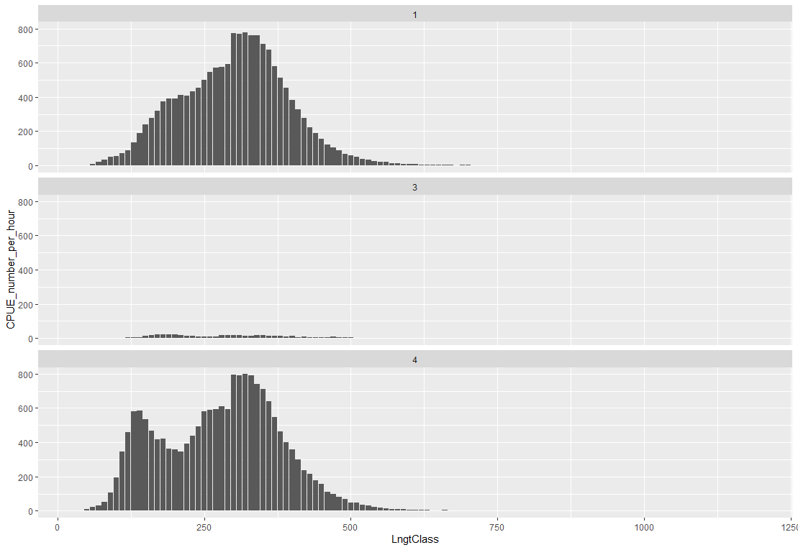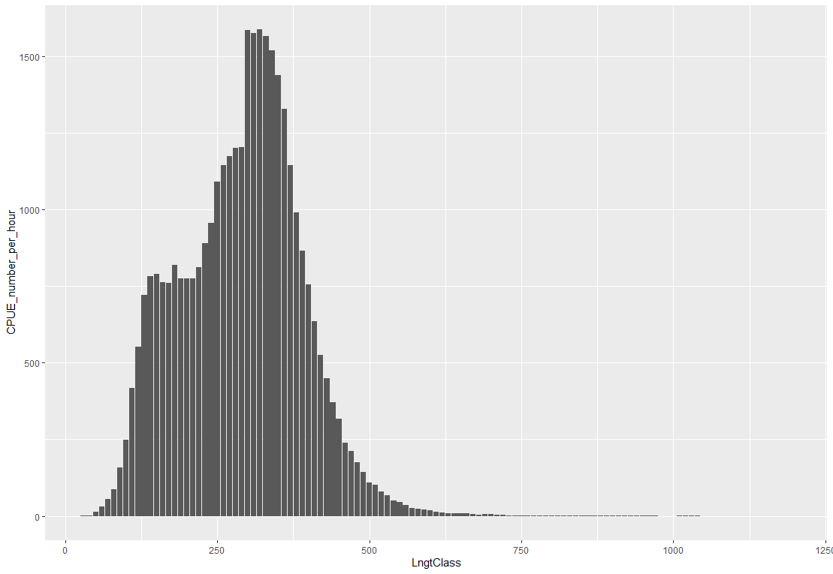Fig.9 includes the CPUE per length classes in area 24 in 3 quarters of the year. units for the length classes are in millimeters and for the CPUE measured as Catch in numbers per hour of hauling.

In comparison to the other areas, this area is similar to area 23 on a different scale. Area 24 experienced the highest abundance of WBC among the others. Also, the appearance of lower-length classes in this area can nominate this area as the nursing pool or spawning area for WBC.

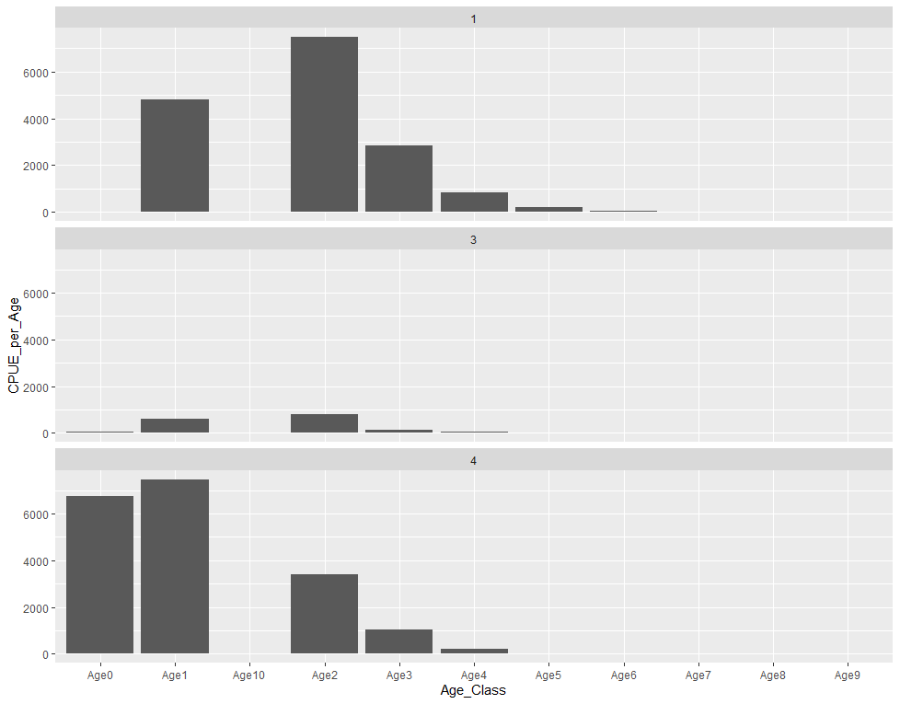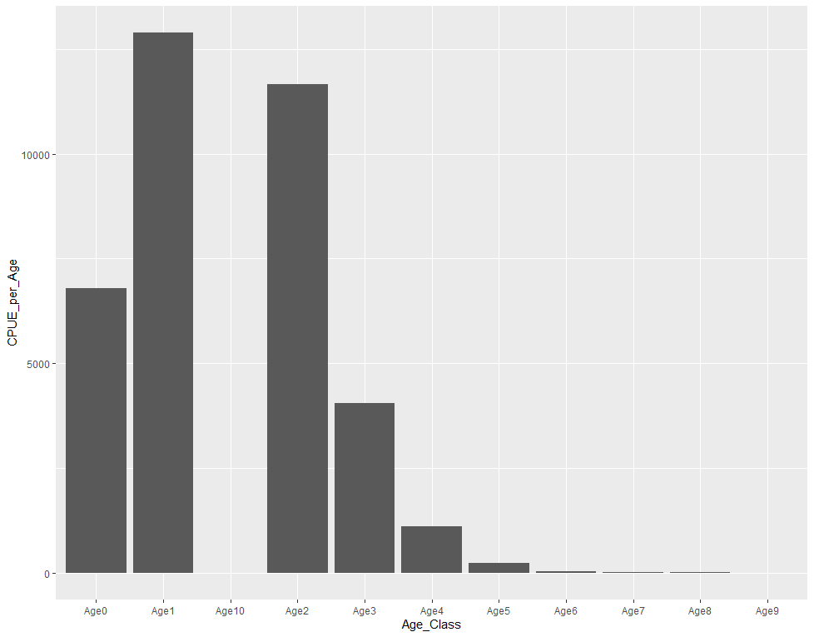

Fig.10 CPUE (Catch in numbers per hour) per age class in area 24 in 3 quarters of the year

A glance at the charts reveals the same results mentioned above in Fig.9. the highest abundance of observations in the first and 2nd age classes indicates the early ages of Growth in WBC in area 24.

introduction

There could be a potential relationship between morphological changes in fish and their catch per unit effort (CPUE) in certain cases. However, this relationship would depend on the specific type of morphological change that occurs in the fish and the environmental conditions in which the fish are living.

For example, if a fish population experiences changes in body shape or size due to environmental factors such as changes in temperature or food availability, it could impact their swimming speed, ability to catch prey, or avoidance of predators. This, in turn, could affect their vulnerability to fishing gear and their catchability, potentially leading to changes in CPUE.

Similarly, if fish experience morphological changes due to overfishing or selective harvesting, such as changes in the size or age structure of the population, it could also impact their vulnerability to fishing gear and their catchability, leading to changes in CPUE.

However, it is important to note that CPUE is a complex metric that can be influenced by many factors, including fishing effort, gear selectivity, and environmental conditions, among others. Therefore, while there may be a relationship between morphological changes and CPUE in certain cases, it would require careful examination and analysis to determine the specific nature of the relationship.

* Biro, P. A., & Post, J. R. (2008). Rapid depletion of genotypes with fast growth and bold personality traits from harvested fish populations. Proceedings of the National Academy of Sciences, 105(8), 2919-2922.
* Jørgensen, C., & Fiksen, Ø. (2010). State-dependent energy allocation in cod (Gadus morhua). Canadian Journal of Fisheries and Aquatic Sciences, 67(12), 1957-1966.
* Law, R. (2000). Fishing, selection, and phenotypic evolution. ICES Journal of Marine Science, 57(3), 659-668.
* Starr, P. J., & Hilborn, R. (2017). Selectivity and the shape of age and size distributions in exploited fish populations. Canadian Journal of Fisheries and Aquatic Sciences, 74(12), 2087-2099.

There are several factors that could contribute to the decline in Gadus morhua (Atlantic cod) catch per unit effort (CPUE) in the West Baltic Sea. Some of the main factors include overfishing, changes in environmental conditions, and disease outbreaks.

Overfishing is a significant threat to the sustainability of Atlantic cod populations worldwide, and the West Baltic Sea is no exception. Historical overfishing has reduced the abundance of cod in this region, and current fishing pressure may still be too high to allow for a recovery of the population. This can result in lower CPUE, as there are fewer fish available to catch.

Changes in environmental conditions, such as temperature and salinity, can also affect the distribution and abundance of Atlantic cod. In the West Baltic Sea, for example, increasing water temperatures may reduce the amount of suitable habitat for cod, or cause them to shift their distribution to cooler waters. This can result in lower CPUE if fishing effort is not adjusted to account for these changes.

Disease outbreaks can also have a significant impact on Atlantic cod populations. For example, outbreaks of the disease cod ulcerative syndrome (CUS) have been linked to declines in cod abundance in the Baltic Sea. CUS can cause skin ulcers, fin rot, and other health problems that can lead to mortality, reduced growth, and reduced catchability, which can contribute to lower CPUE.

It's worth noting that other factors may contribute to the decline in Atlantic cod CPUE in the western Baltic Sea, and the specific causes may vary from year to year. Understanding the complex interactions between fishing pressure, environmental conditions, and other factors is important for developing effective management strategies to promote the recovery of Atlantic cod populations in this region.

* Casini, M., Blenckner, T., Möllmann, C., Gårdmark, A., Lindegren, M., Llope, M., ... & Folke, C. (2016). Hypoxic areas, density-dependence and food limitation drive the body condition of a heavily exploited marine fish predator. Royal Society open science, 3(1), 150489.
* Eero, M., MacKenzie, B. R., Köster, F. W., Gislason, H., & Kjesbu, O. S. (2011). Baltic cod recruitment–the impact of climate variability on key processes. Ices Journal of Marine Science, 68(6), 1059-1068.
* ICES. (2020). Report of the ICES advisory committee on fishery management, advisory committee on the marine environment and advisory committee on ecosystem. ICES Advice, 2020, cod. 22.2.1-11.
* Pulkkinen, K., Suomalainen, L. R., Read, A. F., Ebert, D., & Rintamäki-Kinnunen, P. (2010). Intensive fish farming and the evolution of pathogen virulence: the case of columnaris disease in Finland. Proceedings of the Royal Society B: Biological Sciences, 277(1684), 593-600.

There have been some changes in the mean length of Gadus morhua (Atlantic cod) in the Western Baltic Sea in recent years, although the specific trends may vary depending on the time period and geographic region of interest.

One study, for example, found that the average length of cod caught in the Western Baltic Sea decreased significantly between the 1980s and 2000s, likely due to overfishing and changes in environmental conditions such as temperature and oxygen levels (Lehmann et al., 2011). Another study conducted between 2003 and 2017 found that cod in the Bornholm Basin (a sub-region of the Western Baltic Sea) exhibited declining trends in both mean length and weight, with the most pronounced declines occurring in the early 2000s (Vinther et al., 2018).

These changes in mean length and weight may have implications for the overall health and productivity of Atlantic cod populations in the Western Baltic Sea, as well as for the fishing industry. Understanding the factors driving these changes, including fishing pressure, environmental conditions, and disease outbreaks, is important for developing effective management strategies to promote the recovery and sustainability of cod populations in this region.

* Lehmann, A., Hinrichsen, H. H., Getzlaff, K., & Köster, F. W. (2011). Decreased condition and high rates of atresia in Baltic cod, Gadus morhua, after a decade of declining stock abundance: a sensitive period hypothesis. Marine Ecology Progress Series, 426, 253-265.
* Vinther, M., Nielsen, J. R., Andersen, K. H., & Pedersen, M. W. (2018). Changes in length distribution and biomass of demersal fish communities in the Danish Baltic Sea from 2003 to 2017. Journal of Sea Research, 141, 17-24.

Temperature can affect the morphological change of Atlantic cod in a variety of ways, depending on the specific temperature range and the life stage of the fish. Some examples of the effects of temperature on cod morphology include:

Growth rate: Temperature can influence the growth rate of cod, which in turn can affect their overall size and body shape. Warmer water temperatures generally promote faster growth, resulting in larger fish with relatively shorter bodies and broader heads (Gjøsæter, 1984).

Maturation and reproduction: Temperature can also affect the timing and success of maturation and reproduction in cod. Warmer water temperatures may accelerate maturation and shorten the reproductive season, potentially leading to smaller and less fecund individuals (Brander, 2010).

Muscle structure: Temperature can influence the structure and composition of cod muscle tissue, which can in turn affect their swimming ability and energy use. For example, fish reared in warmer water may have more fast-twitch muscle fibers, which allow for faster swimming but also require more energy (Johansen et al., 2001).

Morphological abnormalities: Extreme temperature fluctuations or prolonged exposure to suboptimal temperatures can lead to morphological abnormalities in cod, such as spinal deformities or changes in fin size and shape (Lindström et al., 2007).

Overall, the effects of temperature on cod morphology are complex and depend on a variety of factors including the specific life stage of the fish, the duration and magnitude of temperature changes, and other environmental conditions. Understanding these relationships is important for predicting and mitigating the impacts of climate change on cod populations in different regions.

* Brander, K. (2010). Effects of climate on cod (Gadus morhua) in the North Atlantic. ICES Journal of Marine Science, 67(5), 927-945.
* Gjøsæter, H. (1984). Stock discrimination and morphometric variation of cod (Gadus morhua L.) from the Norwegian coast. Sarsia, 69(4), 297-307.
* Johansen, S. D., Andersen, Ø., & Vøllestad, L. A. (2001). Muscle fibre recruitment and swimming efficiency in cod (Gadus morhua) at different temperatures. Journal of Experimental Biology, 204(23), 4061-4071.
* Lindström, K., Lundqvist, H., & Nyman, L. (2007). Effects of temperature and oxygen conditions during incubation on egg and yolk-sac larvae of Atlantic cod, Gadus morhua. Marine Biology, 151(3), 1079-1087.

Food availability can also affect the morphological change of Atlantic cod in a variety of ways, depending on the availability and quality of food resources. Some examples of the effects of food availability on cod morphology include:

1. Body size: Food availability can influence the growth rate of cod, which in turn can affect their overall body size and shape. In environments with abundant and high-quality food resources, cod may grow faster and attain larger sizes than in food-limited environments (Corkett et al., 1991).
2. Lipid content: The quality and quantity of food resources can also affect the lipid content and composition of cod tissues. For example, fish consuming a high-fat diet may exhibit higher lipid content in their muscles and liver, which can affect their buoyancy and swimming ability (Brett and Groves, 1979).
3. Skeletal structure: Food availability can also affect the development and maintenance of skeletal structures in cod. In environments with limited food resources, cod may allocate less energy to skeletal growth, resulting in relatively smaller and weaker bones (Rountrey et al., 2005).
4. Morphological abnormalities: Prolonged or severe food limitation can also lead to morphological abnormalities in cod, such as stunted growth, reduced muscle mass, and altered fin shape (Gallagher et al., 2014).

Overall, the effects of food availability on cod morphology are complex and depend on a variety of factors including the quality, quantity, and timing of food resources, as well as the interactions between food availability and other environmental factors such as temperature and salinity. Understanding these relationships is important for predicting and mitigating the impacts of climate change and overfishing on cod populations in different regions.

* Brett, J. R., & Groves, T. D. D. (1979). Physiological energetics. Fish physiology, 8, 280-352.
* Corkett, C. J., Thurston, R. V., & Mellor, G. L. (1991). Effects of feeding on the growth and survival of larval and juvenile cod (Gadus morhua). Canadian Journal of Fisheries and Aquatic Sciences, 48(9), 1723-1733.
* Gallagher, A. J., Franks, B. R., & Cooke, S. J. (2014). Negative effects of starvation on energetics and activity levels of juvenile Atlantic cod. Journal of Experimental Marine Biology and Ecology, 460, 62-69.
* Rountrey, A. N., Coulson, P. G., Meeuwig, J. J., & Meekan, M. G. (2005). Skeletal deformation in presettlement and juvenile coral reef fish: a consequence of feeding habitat? Coral Reefs, 24(1), 127-131.

The size of a cod population or stock can also affect the morphological change of individual cod in a variety of ways. Some examples of the effects of cod stock size on cod morphology include:

1. Body size: The size of a cod population can influence the growth rate of individual cod. In populations with high density or abundance, competition for resources such as food and habitat can result in slower growth rates and smaller body sizes of individual cod (Neuenfeldt et al., 2013).
2. Age and size structure: The age and size structure of a cod population can also influence the morphology of individual cod. For example, in populations with a high proportion of older and larger individuals, younger and smaller individuals may experience greater competition for resources and exhibit slower growth rates and smaller sizes (Ottersen et al., 2013).
3. Reproductive investment: The size of a cod population can also affect the reproductive investment of individual cod. In populations with high abundance, individual cod may invest less in reproduction and allocate more resources to growth and maintenance, resulting in larger body sizes and altered reproductive strategies (Sparholt, 1990).

Overall, the effects of cod stock size on cod morphology are complex and depend on a variety of factors including the density, abundance, and age structure of the population, as well as the interactions between stock size and other environmental and ecological factors such as food availability and temperature. Understanding these relationships is important for managing and conserving cod populations in different regions.

* Neuenfeldt, S., Hinrichsen, H. H., & Köster, F. W. (2013). Environmental and density-dependent effects on the growth of cod (Gadus morhua) in the Baltic Sea. ICES Journal of Marine Science, 70(2), 331-339.
* Ottersen, G., Planque, B., Belgrano, A., Post, E., Reid, P. C., & Stenseth, N. C. (2013). Ecological effects of the North Atlantic Oscillation. Oecologia, 172(1), 1-12.
* Sparholt, H. (1990). Reproductive investment and optimal size in cod (Gadus morhua L.) in relation to fluctuations in stock size. Journal of Fish Biology, 37(supplement A), 123-136.

